СӘЙКЕСТЕНДІРУГЕ ТАПСЫРМА « Дұрыс формуласын тап»

Date: |  |  |  | Teachers name:
Grade: 9 «Zh» |  |  |  | Number present: 26 |  | absent:
Theme of the lesson: |  |  |  | The importance of carbohydrates, proteins and fats in the human body.
Lesson objectives |  | 9.4.1.2 - determine the role of organic matter in the human body;  10.2.4.2- ensuring the pronunciation of chemical formulas
Learning objectives |  | All learners will be able to: Students know the importance of carbohydrates, proteins and fats in the human body.  Most learners will be able to: Students know how to classify carbohydrates, proteins and fats.  Some learners will be able to: knows and can write the formulas of carbohydrates, proteins and fats.
Success criteria |  | Learners knows the benefits and harms of carbohydrates, proteins and fats in food
Plan
Planned timings | Teacher’s activities |  | Pupil’s activities |  | Strategies |  |  | Resources
Beginning  3 min. | Organizational moment:  Teacher greets students. Good morning dear children! How are you today? Who is absent today?  Checks the students’ presence. Asks about date and day of the week.  Teacher divides students into five groups.  And introduces rules in group work.  - Respect each other’s ideas  - Respect the other group members  - Don’t interrupt each other  - Everyone’s opinion should count  - Help each other to understand all concepts  - Keep an open mind  Be happy in the group you are in. |  | Students respond to greeting and take their places.  Students choose color and team according to chosen color. |  | «The praise» method is used to evaluate students with phrases like – Good job! Well done! |  |  | Presentation
Planned timings | Teacher’s activities |  | Pupil’s activities |  | Strategies |  |  | Resources
Middle  5 min  10 min  5 min  5 min  10 min | Teacher introduces lesson objectives.  Works with a glossary by the "balloon" method. Terms on past topics are presented.  The teacher presents a video on the topic.  «Identification» method  The teacher provides students with a table with pictures of different foods.  How to write chemical formulas.  There are several formulas depending on the topic of the lesson.  «Complate the picture» method.  The teacher hands out pre-prepared handouts to students. Each group is given an individual task. |  | Students accept lesson objectives.  One student from each group blows a ball, saying the terms, and the group with the largest ball wins.  Learners Students watch the video and recall their past knowledge.  Students divide the picture into three groups using the picture provided. they are carbohydrates, proteins, fats.  Finds the correct formulas by saying their English names. Identifies formulas.  Құрылымдық формула Қазақша атауы Ағылшынша атауы  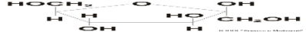 C₆H₁₂O₆ Глюкоза Glucose  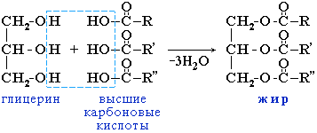 Белок Рroteins  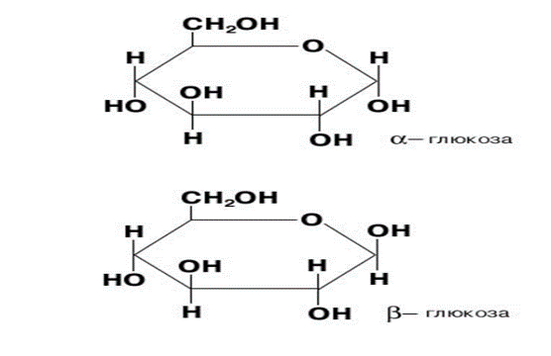 C₆H₁₂O₆ фруктоза Fructose  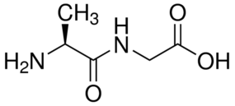 Май Fats  Descriptors:  Білім алушы  − кестеге нәруызды формуласын біледі  − кестеге көмірсуды жіктейді;  − кестеге майды жіктейді;  − кестеге дәруменді жіктейді.  СӘЙКЕСТЕНДІРУГЕ ТАПСЫРМА « Дұрыс формуласын тап»  Көмірсулар формуласы Аталуы  С₁₂ Н₂₂О_{п}; Стеорин қышқылы  С₁₇Н₃₅СООН Глюкоза  (С_{б} Н₁₀ 0₅)п; Олеин қышөылы  С₆ Н₁₂ 0₆; Крахмал  С₁₇Н₃₁СООН Сахороза  Дескриптор  Білім алушы  − кестеге глюкозаның формуласын біледі  − кестеге көмірсуды жіктейді;  − кестеге майды жіктейді;  − кестеден дисахаридтің формуласын таба алады  Make a poster on a given topic, and defend it. |  | Descriptors:  -can pronounce terms correctly;  -can translate terms correctly;  -does not repeat the terms spoken by the other group.  Max score: 5  Question and answer  Descriptors:  -knows what foods are high in protein, carbohydrates and fats;  -knows the English translation of food using the given pictures.  Max score:4  Descriptors:  -students can use the given formulas effectively;  -сan pronounce  formula names correctly;  Max score: 5  Descriptors:  can reveal the content of the lesson;  can effectively use the proposed term words;  can explain the topic given during the defense of the poster;  Max score: 5 |  |  | Presentation  balloons, glossary  https://www.youtube.com/watch?v=d6085sLXCMs  Presentation  Presentation,  Mendeleev table.  Presentation,  posters, handouts
End  3 min. | Reflection and Feedback .  «two stars one wish»  H/t: memorization of terms, writing an essay on "The role of organic and inorganic substances in the human body." |  | Ss raise the color they choose and captains tell their opinion and rate members. |  | Stickers and comments
Additional information

