Short term plan №2
Grade: 9 |  |  | School: school-gymnasium №49 named after Y.Altynsarin
Date: |  |  | The name of the trainee:  Ryssaldy Akbilek
Number of attendees: |  |  | Number of missing:
Theme of the lesson |  | Ақпараттық сипаттар (Information properties)
Learning objectives(s) that this lesson is contributing to (link to the Subject programme) |  | Determining the properties of information
Lesson objectives |  | - acquaintance with the main properties of information;  - determine the properties of information in different situations
Success criteria |  | All students:  Knows the properties of information  Several students:  Can distinguish the properties of information
Language objectives |  | Subject vocabulary and terminology:  өңделген – оброботанный – processed  контекст – контекст – context  өзекті – актуальный – relevant  қасиеттер – свойства – properties  нақты – конкретный – suitable  сыбырлау – шептать – particuler  ишарат – жест – whisper  табу – угадывать – gesture  аңқау – наивный – naive
A series of useful phrases for dialogue/writing:
Who needs help?
Let's look at the next task
Did you complete the task?( тапсырманы орындап болдың ба?)
Let's wait for the other students
Do you have any questions for me?
We will continue…
Giving values |  | - development of communication skills;  - the formation of an information culture, the ability to process information.
Cross-curricular link |  | English, Russian, Kazakh language
Previous learning |  | Компьютерді ұзақ уақыт пайдаланудағы теріс әсерлер (Negative effects of using computer for long time)
Plan
Planned stages of the lesson | Planned activities in the classroom |  |  | Resources
Start  - greet students | How are you?  How is your health?  Who is missing in the lesson?
- homework check | In the previous lesson, you had to translate and write about computer safety in English.  I check to see if each student has completed their homework.  Questions for Review  - What do you know about the harm that computers can do to the human body?  - How to use a computer without harming the body?  - Explain the safety of working with a computer
Middle  New lesson | Today's lesson topic is information properties.  In computer science, information has several properties. they:  Relevance – өзектілігі  - importance to the individual or society;  - benefits in solving a specific problem.  Only timely information can be relevant. For example: “14 .09.2020 at 11:25.  You have 1250 tenge in your account ".  The figure below shows the weather forecast for the next 10 days. The temperature here is only relevant for that day.  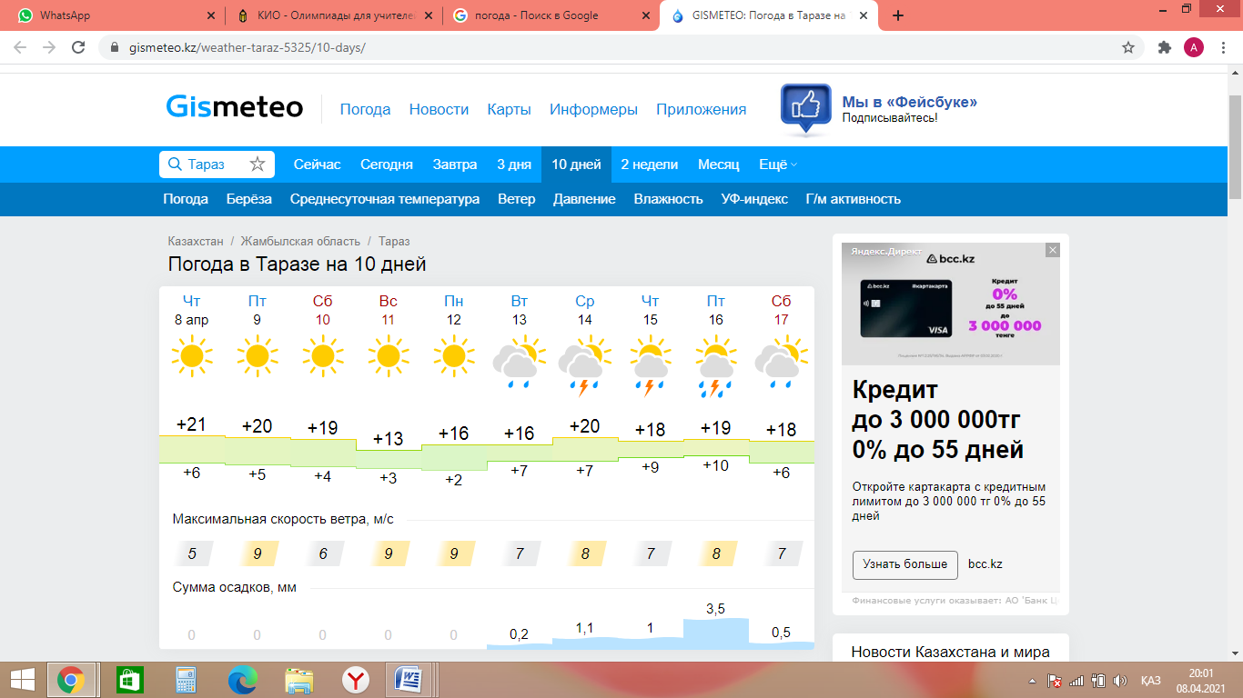  Availability – қолжетімділік  Ability to get information if necessary. For example, if you do not have a computer, you have access to information in a book rather than information on a CD.  Reliability – нақтылығы (сенімділігі)  Information that shows whether the case is true or false. For example, there are 24 hours in 1 day. And to inaccurate information - "There is life on Mars."  Completeness – толықтығы  Sufficient information to make a decision. For example, "My birthday is July 2". Incomplete information - "My birthday is in the summer".  Practice 1. Identify and write the properties of the information given in the table.  2*2=4  Read page 66 of the computer science textbook.  My mother's name is Gulnara Mukiya.  Activity 1. “Broken phone”.  According to the rules of the game, the teacher tells the student one of the terms from today's lesson. The student says the name in English and asks the next student to say the Russian name of the term. In this way, all the terms are repeated until the words are finished. The teacher controls who is right and who is wrong. |  |  | computers, projector
End | So what did we learn in today's lesson? What questions do you have?  To summarize the lesson, we repeat the terms again. |  |  |   https://take.panquiz.com /8622-6617-9917  PIN: 8622-6617-9917
Hometask | Аnswer questions.  Provide information about your friend using all the properties of the information.
Feedback | If everything is clear, let's give feedback. To do this, we like the lesson if you understand it, and dislike it if you do not understand it.  

