LESSON 83  Unit 8: Sports |  |  | School: Kensay
Date: 4.04 |  |  | Teacher’s name: Kopzhasar Dana
Grade: 5 |  |  | Number present: |  | Number absent:
Theme of the lesson: |  | Rules and respect 1  Talking about and writing rules for sports.
Learning objectives |  | 5.R1 understand the main points in a limited range of short simple texts on general and curricular topics  5.W1 plan, write, edit and proof read work at text level with support on a limited range of general and curricular topics  5.UE8 use future forms will for predictions and be going to talk about already decided plans on a limited range of familiar general and curricular topics
Lesson objectives |  | All learners will be able to  - read the text about rules of boxing  - find out the future tense sentences from the given text.  Most learners will be able to  -write the sentences with “will” or “be going to”  Some learners will be able to  -write general rules how to be healthy in the future by using will and be going to forms
Assessment criteria |  | -Apply will and be going to forms correctly in sentences  -Read and identify the main idea of the text
Previous learning |  | Sport for all 2
Plan
Planned  timings | Planned activities |  |  | Learners’ activities | Evaluation | Resources
Beginning  5 min | I Greeting  II Warming up  Video with physical exercises.  III Repetition of the previous lesson  Activity “snowball game” for checking up the vocabulary |  |  | Learners stand around and say words related to the topic sports | Verbal evaluation | Disk
Middle  35 min | Task . Look at the pictures and write the name of sports  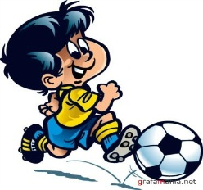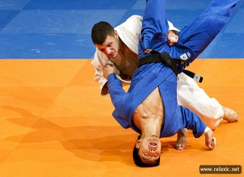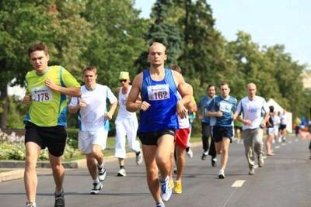  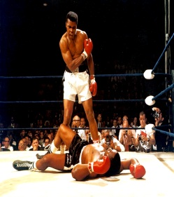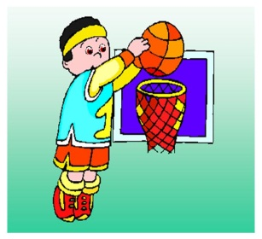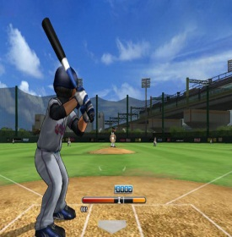  Differentiation :  Task for more able students: write the rules of your favourite sport game.  Activity: Skimming  Rules of Boxing  In professional boxing bouts take place over 12 three minute rounds with one minute rest between round. The only method of attack is punching with a clenched fist and you may not strike below the belt in the kidneys or the back of your opponents head or neck. You cannot use the ropes for leverage. You cannot hit an opponent when they are down . A boxer hit with a low blow can take five minutes to recover. If an unintentional foul (such as clash of heads) end the fight before four rounds are completed this is a “no contest” from the fifth onwards the decision goes to the judge’s cards and is either a technical decision for either fighter or a technical draw.  Questions:  How many rounds could be in professional boxing bouts?  How many minutes are there between rounds?  How might you strike your opponents?  When does the boxer can take five minutes rest? |  |  | Learners write the rules of your favourite sport game  Learners read the text and answer the questions below | Individual avaluation  Mutual avaluation | Pictures  http://www.rules sport.com
End  5 min | Reflection  2 stars and a wish  For reflection and feedback ask learner to give 2 stars and one wish concerning the lesson  Two stars = 2 things that they understand  about the lesson (text will/be going to)  A wish = something they can improve  to make it even better (on the text, will/be going to)  Home task: Make up your own sentences with “ to be going to” .  Saying goodbye |  |  |  | Self-assessment

