Leader Innovation School
Short term plan for English lesson
The theme: Modal verbs
Teacher’s name:  Checked by: | Primkulova Madina  Burkitbayeva A.S.
School | Leader Innovation School
Grade: | 6th grade
Date | 25.02.2022
Theme of the lesson : Modal verbs MUST, HAVE TO, SHOULD.
Lesson objectives: | Learners will be able to:  - Recognize and pronounce greetings  - Read the text and answer simple questions  - All learners give some opinion with lots of support  - Most learners give some opinion with some support  - Some learners give some opinion independently
Assessment criteria: | Learners will have succeeded in this class if they:  - Reply to 5 and more questions and phrases correctly  - Recognize 4 or more phrases and pronounce them intelligibly
Cross curricular links | Kazakh, Russian, English
ICT skills | PPT-teacher cards, flashcards, books, worksheets

Differentiated learning tasks

Teamwork |  | Collective work (tasks) | Individual work
Time | Phases | Tasks | Task objectives | Resources
3 min | Organiza  tional moment | Goog morning, my dear students. Sit down, please. Glad to see you. Hope you are well today. Let’s start our lesson with some common questions. What date/day is it today? |  | Flashcards  Books  Internet resources
10 min | Explaining new theme | - We are going to learn some new grammar material. I’ll tell you about some modal verbs (must, have to, should ) and try to explain you the difference between them, then we’ll do some exercises. But at the beginning of our lesson let’s revise some main verbs.  Play chess, work hard, study at school, learn English, speak French, sleep a little, get up early, go back home, look for, take care of, look after, listen to teacher, write down some tasks.  Explanation of the new theme.  Must:  (+) We must be at the station at 5 o’clock in the evening (қажет)  (-) mustn’t (болмайды)  (-) needn’t (қажет емес)  Have to:  (+) You have to get ready for your test on literature (қажет, керек)  (-) needn’t ( қажет емес, керек емес)  Should:  (+) You should see that film. It’s very good. (абзал, дұрыс)  (-) shouldn’t (істемегенің дұрыс, абзал)  Questions  A. Must I phone them at once?-  1. Yes, you must (ия міндеттісің)  2. No, you needn’t (жоқ, қажет емес)  B. Must we turn right here?-  1. Yes, we must (ия міндетті түрде)  2.No, we mustn’t (жоқ, міндетті емес)  3.No, we needn’t (жоқ, қажет емес) | Learners  will master the topic by listening the teacher
5 min | Collective  Practice | Физкультминутка  And now, please, do the following exercises.  Stand up!  Step-step! Clap-clap!  Turn yourself around.  The hands upon the head you place.  On the shoulders,  On the face.  Then put them in front of you  And gently clap: one, two, three. | Learners will practice new words by doing task under the supervision of a teacher
25 min |  | Activity №1. Team work.  Three clouds with three words /advice, prohibition, no obligation/ are hung on the board. Divide the class into 3 groups. 1-group will choose the sentences with advice. 2-group will choose the sentences with prohibitions. 3-group will collect the sentences with no obligations.  The first finished group will be the winner.  I _________________ (1) go to school from Monday to Friday. We ___________________ (2) wear a uniform, so I normally wear sports clothes. We ___________________ (3) arrive late, and we ___________________ (4) go to every class. In class, we __________________ (5) shout, play or sing. We _____________________ (6) have lunch at school, so I sometimes go home. When school finishes, I ___________________ (7) look after my little sister. When my parents come home I ___________________ (8) stay in, so I usually go out with my friends. When I get home, I ___________ (9) do my homework. I ____________________ (10) go to bed late. But on Fridays, when I ________________ (11) go to bed before midnight.  Activity №2. Individual work. Play with the wheel of fortune.  Make one sentence form the chosen modal verb.  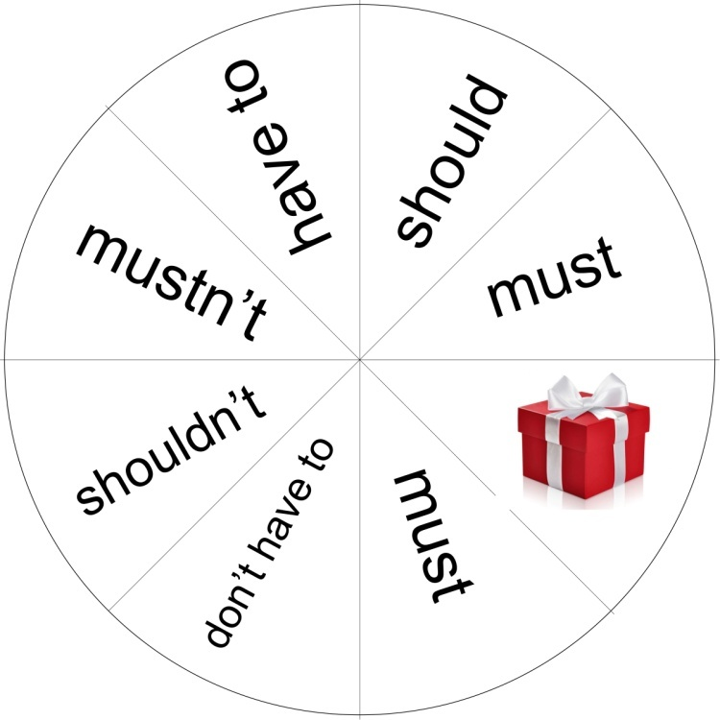  Activity №3. Work in pairs. Ss are given cards with tasks.  Activity №4. On the board there are hung frogs with a sentence consisting modal verbs on the back site. Students choose one frog and translate the sentence from English into Kazakh.  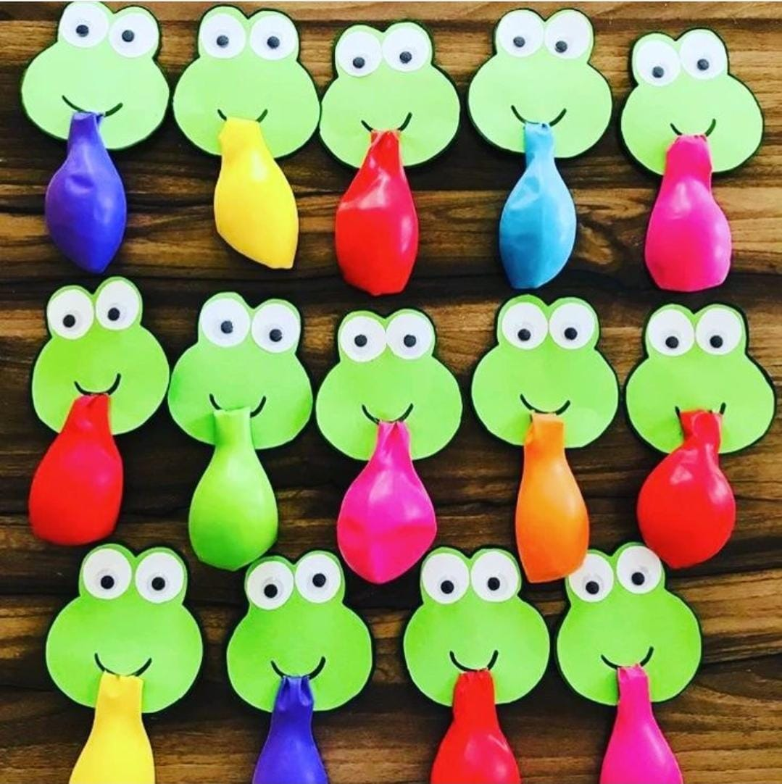 | Recognize new words and pronounce them intelligibly  Be able to work individually and make a solution quickly. | Worksheet
5 min | End | At the end of the lesson learners complete an evaluation of what they did during the lesson by showing one of the three colors.  Feedback  Green star – I understand very well  Yellow star – I understand normally  Red star – It was difficult to understand  Homework: Lean up all words given during the lesson. Be ready to answer question about adjectives  Do 2 exercises given in the worksheets.  The lesson is over. I'm really pleased with you and your work at the lesson. You've tried your best and I'll put you excellent marks. |  | Colored paper leaves

Additional information

Differentiation – how do you plan to give more support? How do you plan to challenge the more able learners? | Assessment – how are you planning to check learner’s learning?
More support can be given in the middle of the lesson by providing less able learners with story vocabulary in a word list, so they can see picture of them.  More able learners can be encouraged to read the story without any support | Monitor learners as they read the story, active participation in discussions.  They can read and understand each event. Notice any sentences which are difficult for learners to understand and adapt for a future lesson.

